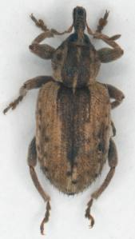
Alfalfa Weevil
Adult weevils are starting to emerge from overwintering in the alfalfa in some southern counties. Even though it has been cold, the alfalfa weevil will emerge when temperatures reach 60⁰ F in spring and start feeding on growing alfalfa. These weevils are roughly ¼ inch with a brownish-gray snout and a dark brown band down the center of their back. It is important to remember that they will not lay eggs for a few more weeks; this gives the grower a window of opportunity to eliminate the population through two methods.
The first and easiest method is timely cutting of alfalfa which can eliminate low weevil populations. By cutting within a week of weevil presence at early bloom or bud break, the vast majority of weevils will be killed by outside factors. The open canopy will reduce food, shelter and increase sunlight. An open canopy will also help introduce beneficial insects such as lady bugs, lacewings and damsel bugs that feed on weevils.
If immediate cutting is not a possibility the second solution is to spray. An immediate application of either dimethoate, chlorpyrifos, or Silencer at full rates are recommended to kill large weevil populations. Rates are as follows: silencer @ 3.84oz (PHI is 7 days), Dimethoate @ 1.5 pints (PHI is 10 days), Chlorpyrifos @ 1 qt (PHI is 21 days). NEW for this year is Paradigm insecticide, it is Silencer reconditioned to be more user friendly with low odor! Keep in mind that Paradigm and Chlorpyrifos have CAUTION labels where as Dimethoate and Silencer have WARNING labels. These insecticides can be lethal to bees, check to make sure there are no colonies nearby.
Treatments are recommended when larval counts are 1.5 – 2 per stem or when larvae average 20 per 180⁰ sweeps. Currently growers in southern counties are seeing low counts of 1-19 per 100 sweeps with an average of 3 per 100. Systematic sampling should begin around 300 degree days.

- Dimethoate and Chlorpyrifos are trademarks of Drexel
- Silencer and Paradigm are trademarks of MANA
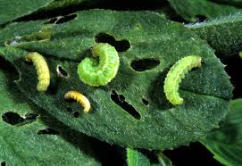
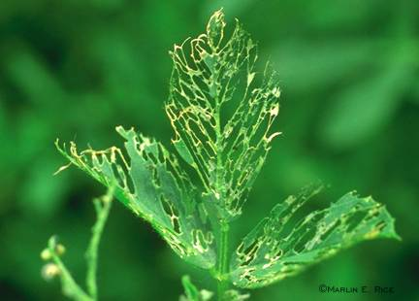
- Please read and follow all labels and directions…

Alfalfa Weevil Defoliation. Weevil larvae

